AIR UNIVERSITY, ISLAMABAD



Department of Computer Sciences

FACULTY OF COMPUTING AND ARTIFICIAL INTELLIGENCE

Operating Systems Lab-CS225L

**Lab:** 02

**Topic:** Liunx Commands

**Lab Instructor:**

## Instructions:

**Plagiarism:** Plagiarism cases will be dealt with strictly. If found plagiarized, both the involved parties will be awarded zero marks in this assignment, all of the remaining assignments, or even an F grade in the course. Copying from the internet is the easiest way to get caught!

**Deadline:** Late submission with marks deduction will be accepted according to the course policy shared earlier. Correct and timely submission of the assignment is the responsibility of every student; hence no relaxation will be given to anyone.

**Tip:** For timely completion of the assignment, start as early as possible. Furthermore, work smartly - as some of the problems can be solved using smarter logic.

1. Note: Follow the given instructions to the letter, failing to do so will result in a zero.

## Objectives:

In this lab, you will learn basic Linux commands.

**Basic Commands**

* **pwd** (present working directory)

Shows in which directory you are present/working. There is nothing like C,D,E drives in Linux, everything is based on root folder.

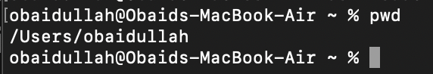

* **ls ( list directory contents)**

# Description

Lists all files and folders present in the current directory.

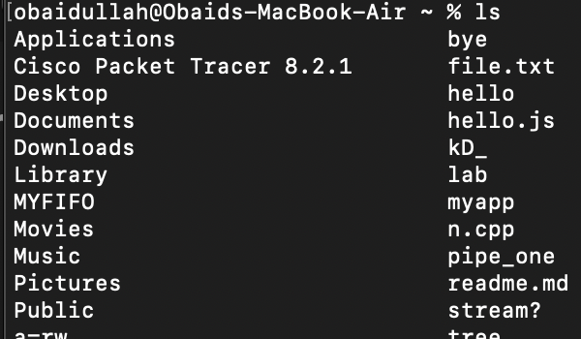

# Clear

Term used to describe the process of removing all text or images from a section of the screen. When working with text, a user may use the backspace or delete key on their keyboard to clear any text. Users trying to clear all the information on their screen at a command prompt may use the "clear" command in Linux/ Unix.

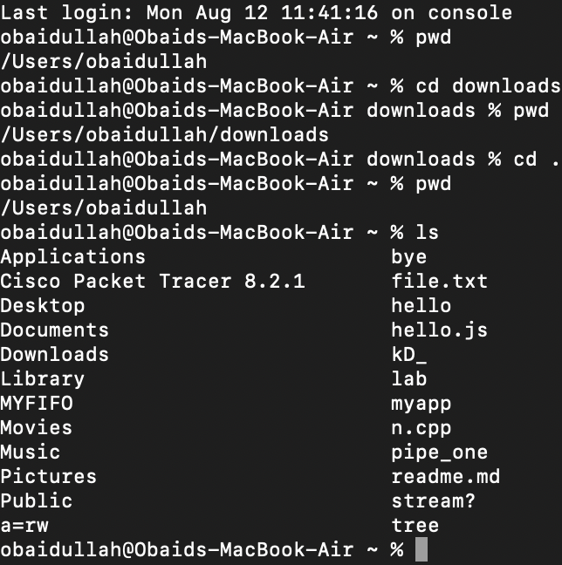

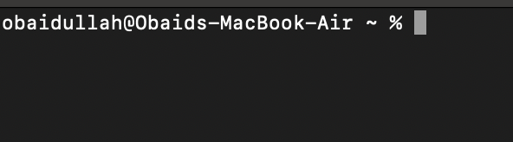

### Touch

Used to create a text file Syntax

#### touch test.txt

The touch command is the easiest way to create new, empty files. It is also used to change the timestamps (i.e., dates and times of the most recent access and modification) on existing files and directories.

When used without any options, touch creates new files for any file names that are provided as arguments (i.e., input data) if files with such names do not already exist. Touch can create any number of files simultaneously.

Thus, for example, the following command would create three new, empty files named file1, file2 and file3:

### touch file1 file2 file3

To make file in another directory

### touch ~/newFolder/AnotherFolder/NewFile.txt

To make multiple files in another directory

**touch ~/Folder1/Folder2/NewFile.txt ~/Folder1/Folder2/NewFile.txt**

# 

# Mkdir

Short for make directory, mkdir is a command used in Linux, Unix, Windows command line, as well as FTP sessions to create new directories.

# Syntax

* + **CD**

### mkdir mydirectory

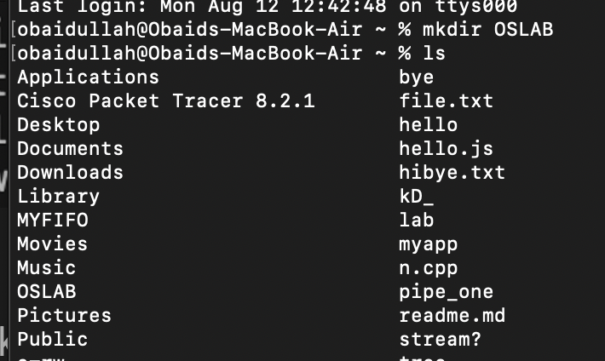

Short for Change Directory, cd is a command commonly used to change the directory in a command line operating system.

**Syntax**

#### cd mydirectory

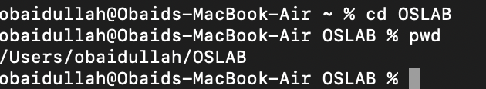

* + - To come back to the root directory

**cd ~** (tilda)

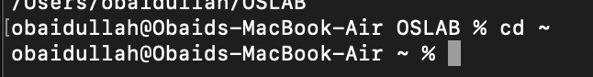

* + - To navigate to another directory within

### cd ~/Folder/AnotherFolder

* + - To move the file into the directory

### mv test.txt mydirectory

### 

* + - Copy command

### cp test2.txt mydirectory

* + - Remove file

### rm test2.txt

* + - Remove directory
    - [cal](http://ss64.com/bash/bc.html) Display calendar
    - [date](http://ss64.com/bash/date.html) Display the date & time
    - [echo](http://ss64.com/bash/echo.html) Display message on screen
    - [free](http://ss64.com/bash/echo.html) Display memory usage
    - [id](http://ss64.com/bash/id.html) Print user and group id's
    - [ps](http://ss64.com/bash/ps.html) Process status
    - man help manual

**Tasks**

* **Using Linux commands mimic the cut scenario.**
* **Using Linux commands print your name on the screen.**